Practical No. 7
Aim : ALP to perform block transfer Without using String Instruction.

Name : Danish Altaf Solkar Class : CO - B
Enrolment no. : 24111590805 Batch : 2

Code :-
assume cs:code
assume ds:data
data segment
arr1 DB 10H,20H,30H,40H,50H
arr2 DB 5 DUP(?)
data ends
code segment
start:
MOV AX,data
MOV DS,AX
MOV AX,0000H
LEA SI,arr1
LEA DI,arr2
MOV CL,05H
idhar:
MOV AL,[SI]
MOV [DI],AL
INC SI
INC DI
LOOP idhar
INT 03H
code ends
end start

OUTPUT :-
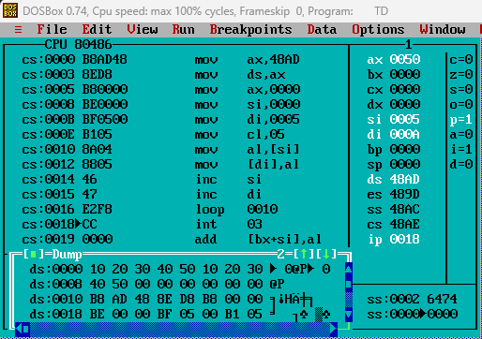

Process related  (15) | Product related  (10) | Total Marks  (25) | Signature

